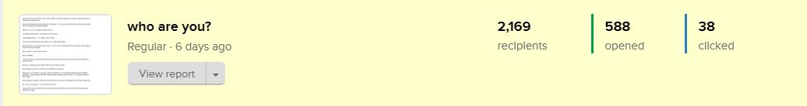

588 people opened this email: https://preview.mailerlite.com/n7i4j3

------------------------------------------------------------------------------------------

Headline: who are you?
———————————————-

You’re the only one at home. You’re in the middle of a general staff zoom meeting - giving a speech on behalf of your department.

Then these footsteps interrupt your train of thought - you excuse yourself from the meeting to go check who it is, hoping it’s someone familiar.

Sadly, it’s not - It’s me and you don’t know me.

You walk towards where I am and ask “who are you?”

I immediately tell you - “I’m selling a juice maker”.

You’ll look at me with disgust and suspect I’m a Yaba left escapee.

Not because you don’t need a juice maker - in fact, you've reached the end of jumia and konga and they don’t have it available.

Why wouldn’t you just buy from me?

Was I smelling?

I have a product you desperately need with a discount attached for you and any of your staff-friends you refer to me.

Because I badged into your space without even knocking, right?

Even though you know I seemed very confident in my product.

Why was I in your place? I saw you made a comment on a Jumia product page (with your address attached) - about searching the whole internet without finding a juice maker. So, I thought you’d be a good target.

Dear Instagram vendors, all this gist is to show you how you are no different from that juice maker guy?

All I see on your page is “come and buy, buy, buy!”.

Put yourself in your customers shoes and picture what that feels like, when they scroll through your sales-driven page.

Do you like what you see?
Maybe this is why they don’t - comment, like, share, save, and even buy?

All you need to do is knock first. Knock the door of their hearts - with a story.

The Storywriting Bootcamp is up. We start in June, and as you know I only take 25 students. Let me teach you how to knock.

Lamide.

